**Test 1 : Create new consumer**

// to create new consumer we need to provide new EMAIL , DO NOT INPUT consumerid or, consumerProfileId

{

"regionId": "d890342d-fcc4-4d4d-2f11-08d5483c74a8",

"country": "USA",

"email": "dangdd6@yahoo.com.vn",

"firstName": "Dinh",

"lastName": "Dang",

"handicapRange": 19,

"gender": "m",

"postalCode": "12345",

"phoneHome": 976094792,

"description": "Description for Dang",

"handicap": 13,

"dob": "1976-12-15T15:49:14Z",

"rpm": null,

"systemId": "70943dc7-1fb0-47f5-c090-08d548a143ba"

}

If we don’t put the regionId in the response, we will get the error message

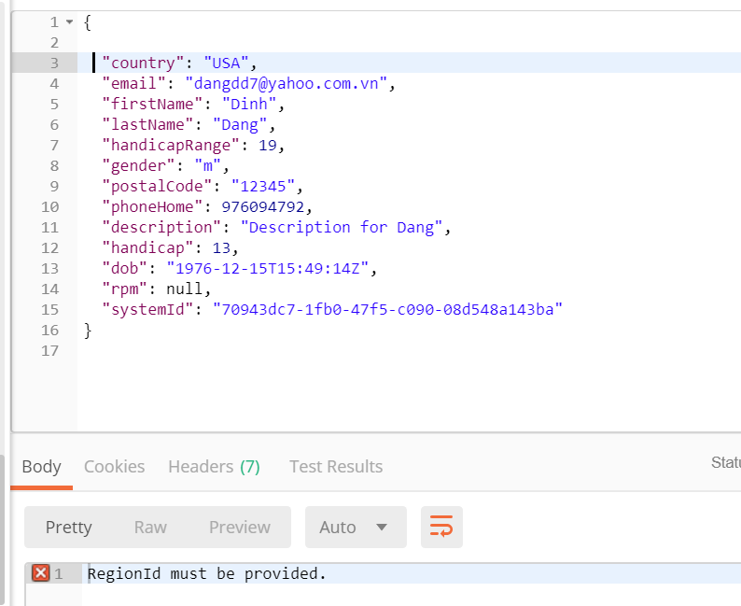

And the result like below:

**System wil create new consumer and new customer profile also**

|  |
| --- |
| {  "id": "01407eb7-e3cb-4971-b7bb-08d6af376450",  "primaryEmail": "dangdd6@yahoo.com.vn",  "firstName": "Dinh",  "lastName": "Dang",  "firstNameKana": null,  "lastNameKana": null,  "dob": "1976-12-15T15:49:14Z",  "gender": "m",  "genderId": null,  "consumerProfiles": [  {  "id": "a5d0ed4e-c472-44c9-a5fb-08d6af376452",  "regionId": "d890342d-fcc4-4d4d-2f11-08d5483c74a8",  "phoneHome": "976094792",  "phoneCell": null,  "notes": "Description for Dang",  "memberRank": null,  "addressId": "21e7a37f-8ebd-4e28-f259-08d6af376452",  "consumerId": "01407eb7-e3cb-4971-b7bb-08d6af376450",  "address": {  "id": "21e7a37f-8ebd-4e28-f259-08d6af376452",  "addressLine1": null,  "addressLine2": null,  "addressLine3": null,  "city": null,  "state": null,  "zipCode": "12345",  "country": "USA",  "systemId": "70943dc7-1fb0-47f5-c090-08d548a143ba",  "consumerBagPanelCampaign": null,  "retailStore": null,  "system": null,  "consumerExperiences": null,  "created": "2019-03-23T02:29:36.0464436Z",  "createdBy": "6ae9372e-e8c7-4a62-9ea9-9ea93ed9af97",  "modified": "2019-03-23T02:29:36.046448Z",  "modifiedBy": "6ae9372e-e8c7-4a62-9ea9-9ea93ed9af97"  },  "region": null,  "consumerExperiences": null,  "systemToConsumerProfiles": [  {  "id": "08fd3b8b-d3e8-40b4-9b22-08d6af376454",  "consumerProfileId": "a5d0ed4e-c472-44c9-a5fb-08d6af376452",  "systemId": "70943dc7-1fb0-47f5-c090-08d548a143ba",  "system": null,  "created": "2019-03-23T02:29:36.0464611Z",  "createdBy": "6ae9372e-e8c7-4a62-9ea9-9ea93ed9af97",  "modified": "2019-03-23T02:29:36.0464611Z",  "modifiedBy": "6ae9372e-e8c7-4a62-9ea9-9ea93ed9af97"  }  ],  "consumerOptIns": null,  "created": "2019-03-23T02:29:36.0464257Z",  "createdBy": "6ae9372e-e8c7-4a62-9ea9-9ea93ed9af97",  "modified": "2019-03-23T02:29:36.0464283Z",  "modifiedBy": "6ae9372e-e8c7-4a62-9ea9-9ea93ed9af97"  }  ],  "golferProfile": {  "id": "a209de96-28ff-4c1d-37f8-08d6af376455",  "consumerId": "01407eb7-e3cb-4971-b7bb-08d6af376450",  "roundsPerMonth": 0,  "driverLoftId": null,  "currentDriverFlexId": null,  "currentDriverBallFlight": null,  "desiredDriverBallFlight": null,  "typicalDriverDistance": null,  "currentIronLengthId": null,  "current7IronBallFlight": null,  "desired7IronBallFlight": null,  "typical7IronDistance": null,  "handicap": 13,  "clubHandId": null,  "whatsInTheBags": null,  "desiredDriverFlexId": null,  "currentIronLieId": null,  "currentIronLength": null,  "currentDriverFlex": null,  "driverLoft": null,  "currentIronLie": null,  "desiredDriverFlex": null,  "clubHand": null,  "created": "2019-03-23T02:29:36.0464688Z",  "createdBy": "6ae9372e-e8c7-4a62-9ea9-9ea93ed9af97",  "modified": "2019-03-23T02:29:36.0464728Z",  "modifiedBy": "6ae9372e-e8c7-4a62-9ea9-9ea93ed9af97"  },  "consumerBagPanelCampaigns": null,  "genderLookUp": null,  "deleted": null,  "created": "2019-03-23T02:29:36.0463619Z",  "createdBy": "6ae9372e-e8c7-4a62-9ea9-9ea93ed9af97",  "modified": "2019-03-23T02:29:36.0463845Z",  "modifiedBy": "6ae9372e-e8c7-4a62-9ea9-9ea93ed9af97"  } |

**Test case 2 : Update Consumer Data by Consumer Id with multiple consumer profile :**

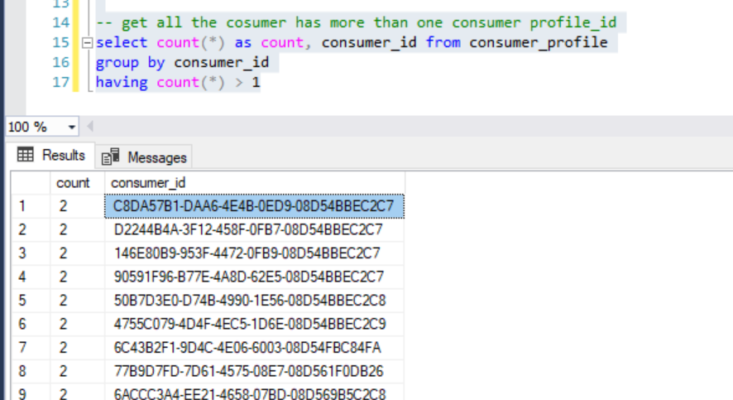

{

"consumerId":"C8DA57B1-DAA6-4E4B-0ED9-08D54BBEC2C7",

"regionId": "d890342d-fcc4-4d4d-2f11-08d5483c74a8",

"country": "USA",

"firstName": "Dinh",

"lastName": "Dang",

"handicapRange": 19,

"gender": "m",

"postalCode": "12345",

"phoneHome": 976094792,

"description": "Description for Dang",

"handicap": 13,

"dob": "1976-12-15T15:49:14Z",

"rpm": null,

"systemId": "70943dc7-1fb0-47f5-c090-08d548a143ba"

}

And the result like below :

|  |
| --- |
| {  "id": "c8da57b1-daa6-4e4b-0ed9-08d54bbec2c7",  "primaryEmail": "elisha.elizabeth@gmail.com",  "firstName": "Dinh",  "lastName": "Dang",  "firstNameKana": null,  "lastNameKana": null,  "dob": "1976-12-15T15:49:14Z",  "gender": "m",  "genderId": null,  "consumerProfiles": [  {  "id": "53324e16-7323-4324-2861-08d54bbec2d0",  "regionId": "d890342d-fcc4-4d4d-2f11-08d5483c74a8",  "phoneHome": "976094792",  "phoneCell": null,  "notes": "Description for Dang",  "memberRank": null,  "addressId": "6e452a47-6189-47d7-958d-08d6aee18406",  "consumerId": "c8da57b1-daa6-4e4b-0ed9-08d54bbec2c7",  "address": {  "id": "6e452a47-6189-47d7-958d-08d6aee18406",  "addressLine1": null,  "addressLine2": null,  "addressLine3": null,  "city": null,  "state": null,  "zipCode": "12345",  "country": "USA",  "systemId": "70943dc7-1fb0-47f5-c090-08d548a143ba",  "consumerBagPanelCampaign": null,  "retailStore": null,  "system": null,  "consumerExperiences": null,  "created": "2019-03-23T02:32:54.5539065Z",  "createdBy": "6ae9372e-e8c7-4a62-9ea9-9ea93ed9af97",  "modified": "2019-03-23T02:32:54.5539572Z",  "modifiedBy": "6ae9372e-e8c7-4a62-9ea9-9ea93ed9af97"  },  "region": null,  "consumerExperiences": null,  "systemToConsumerProfiles": [  {  "id": "6e264bfc-5dc1-40f5-386c-08d54bbec2d7",  "consumerProfileId": "53324e16-7323-4324-2861-08d54bbec2d0",  "systemId": "d6f3a36b-d2e6-4182-8001-08d5483ce271",  "system": null,  "created": "2017-12-25T18:08:18.7363918",  "createdBy": "00000000-0000-0000-0000-000000000000",  "modified": "2019-03-23T02:32:54.5539634Z",  "modifiedBy": "6ae9372e-e8c7-4a62-9ea9-9ea93ed9af97"  },  {  "id": "d57ef6ae-13cc-494a-9e5d-08d5ae98f2a9",  "consumerProfileId": "53324e16-7323-4324-2861-08d54bbec2d0",  "systemId": "a1f3a36b-d2e6-4182-8001-08d5483ce271",  "system": null,  "created": "2018-05-02T21:10:16.3887932",  "createdBy": "6ae9372e-e8c7-4a62-9ea9-9ea93ed9af97",  "modified": "2019-03-23T02:32:54.5540815Z",  "modifiedBy": "6ae9372e-e8c7-4a62-9ea9-9ea93ed9af97"  },  {  "id": "1a27f7ac-f30a-4243-f1d5-08d6aee1840c",  "consumerProfileId": "53324e16-7323-4324-2861-08d54bbec2d0",  "systemId": "70943dc7-1fb0-47f5-c090-08d548a143ba",  "system": null,  "created": "2019-03-22T16:14:52.4960311",  "createdBy": "6ae9372e-e8c7-4a62-9ea9-9ea93ed9af97",  "modified": "2019-03-23T02:32:54.5540906Z",  "modifiedBy": "6ae9372e-e8c7-4a62-9ea9-9ea93ed9af97"  }  ],  "consumerOptIns": [],  "created": "2017-12-25T18:08:18.7363753",  "createdBy": "00000000-0000-0000-0000-000000000000",  "modified": "2019-03-23T02:32:54.5539462Z",  "modifiedBy": "6ae9372e-e8c7-4a62-9ea9-9ea93ed9af97"  },  {  "id": "72e6658f-eff2-4626-6979-08d63fd5b24a",  "regionId": "d890342d-fcc4-4d4d-2f11-08d5483c74a8",  "phoneHome": "976094792",  "phoneCell": null,  "notes": "Description for Dang",  "memberRank": null,  "addressId": "ed2072fa-6c1f-4257-1629-08d6aee4cea2",  "consumerId": "c8da57b1-daa6-4e4b-0ed9-08d54bbec2c7",  "address": {  "id": "ed2072fa-6c1f-4257-1629-08d6aee4cea2",  "addressLine1": null,  "addressLine2": null,  "addressLine3": null,  "city": null,  "state": null,  "zipCode": "12345",  "country": "USA",  "systemId": "70943dc7-1fb0-47f5-c090-08d548a143ba",  "consumerBagPanelCampaign": null,  "retailStore": null,  "system": null,  "consumerExperiences": null,  "created": "2019-03-23T02:32:54.5539083Z",  "createdBy": "6ae9372e-e8c7-4a62-9ea9-9ea93ed9af97",  "modified": "2019-03-23T02:32:54.5541048Z",  "modifiedBy": "6ae9372e-e8c7-4a62-9ea9-9ea93ed9af97"  },  "region": null,  "consumerExperiences": null,  "systemToConsumerProfiles": [  {  "id": "803bb1ff-e300-49bb-fbb5-08d63fd5b24c",  "consumerProfileId": "72e6658f-eff2-4626-6979-08d63fd5b24a",  "systemId": "a1f3a36b-d2e6-4182-8001-08d5483ce271",  "system": null,  "created": "2018-11-13T19:44:47.1016545",  "createdBy": "6ae9372e-e8c7-4a62-9ea9-9ea93ed9af97",  "modified": "2019-03-23T02:32:54.5541074Z",  "modifiedBy": "6ae9372e-e8c7-4a62-9ea9-9ea93ed9af97"  },  {  "id": "cf3663ea-7ded-4df9-29cb-08d6aee4cea6",  "consumerProfileId": "72e6658f-eff2-4626-6979-08d63fd5b24a",  "systemId": "70943dc7-1fb0-47f5-c090-08d548a143ba",  "system": null,  "created": "2019-03-22T16:38:26.1856976",  "createdBy": "6ae9372e-e8c7-4a62-9ea9-9ea93ed9af97",  "modified": "2019-03-23T02:32:54.5541103Z",  "modifiedBy": "6ae9372e-e8c7-4a62-9ea9-9ea93ed9af97"  }  ],  "consumerOptIns": [  {  "id": "151e4498-e219-4c50-f7b9-08d6407d85e4",  "consumerProfileId": "72e6658f-eff2-4626-6979-08d63fd5b24a",  "key": "NEWS_TAYLORMADE",  "value": null,  "created": "2018-11-13T19:47:31.9092631",  "createdBy": "6ae9372e-e8c7-4a62-9ea9-9ea93ed9af97",  "modified": "2019-03-23T02:32:54.5541698Z",  "modifiedBy": "6ae9372e-e8c7-4a62-9ea9-9ea93ed9af97"  }  ],  "created": "2018-11-13T19:44:47.1016421",  "createdBy": "6ae9372e-e8c7-4a62-9ea9-9ea93ed9af97",  "modified": "2019-03-23T02:32:54.5541005Z",  "modifiedBy": "6ae9372e-e8c7-4a62-9ea9-9ea93ed9af97"  }  ],  "golferProfile": {  "id": "680def32-6c42-41a9-8fa6-08d54bbec2dc",  "consumerId": "c8da57b1-daa6-4e4b-0ed9-08d54bbec2c7",  "roundsPerMonth": 0,  "driverLoftId": null,  "currentDriverFlexId": null,  "currentDriverBallFlight": null,  "desiredDriverBallFlight": null,  "typicalDriverDistance": null,  "currentIronLengthId": null,  "current7IronBallFlight": null,  "desired7IronBallFlight": null,  "typical7IronDistance": null,  "handicap": 13,  "clubHandId": null,  "whatsInTheBags": null,  "desiredDriverFlexId": null,  "currentIronLieId": null,  "currentIronLength": null,  "currentDriverFlex": null,  "driverLoft": null,  "currentIronLie": null,  "desiredDriverFlex": null,  "clubHand": null,  "created": "2017-12-25T18:08:18.7364058",  "createdBy": "00000000-0000-0000-0000-000000000000",  "modified": "2019-03-23T02:32:54.5541884Z",  "modifiedBy": "6ae9372e-e8c7-4a62-9ea9-9ea93ed9af97"  },  "consumerBagPanelCampaigns": null,  "genderLookUp": null,  "deleted": null,  "created": "2017-11-06T21:46:37",  "createdBy": null,  "modified": "2019-03-23T02:32:54.5539181Z",  "modifiedBy": "6ae9372e-e8c7-4a62-9ea9-9ea93ed9af97"  } |

**Test case 3 : Update consumer data by Consumer profile Id**

{

"consumerProfileId":"913ac0cd-9b28-4113-8163-08d6aedd6f20",

"regionId": "d890342d-fcc4-4d4d-2f11-08d5483c74a8",

"country": "USA",

"firstName": "Dinh",

"lastName": "Dang",

"handicapRange": 19,

"gender": "m",

"postalCode": "12345",

"phoneHome": 976094792,

"description": "Description for Dang",

"handicap": 13,

"dob": "1976-12-15T15:49:14Z",

"rpm": null,

"systemId": "70943dc7-1fb0-47f5-c090-08d548a143ba"

}

And the response

|  |
| --- |
| {  "id": "12ec2a66-4b83-4cf0-91d8-08d6aedd6f15",  "primaryEmail": "dangdd3@yahoo.com.vn",  "firstName": "Dinh",  "lastName": "Dang",  "firstNameKana": null,  "lastNameKana": null,  "dob": "1976-12-15T15:49:14Z",  "gender": "m",  "genderId": null,  "consumerProfiles": [  {  "id": "913ac0cd-9b28-4113-8163-08d6aedd6f20",  "regionId": "d890342d-fcc4-4d4d-2f11-08d5483c74a8",  "phoneHome": "976094792",  "phoneCell": null,  "notes": "Description for Dang",  "memberRank": null,  "addressId": "4fdda04f-162f-47ad-1b5e-08d6aede87f8",  "consumerId": "12ec2a66-4b83-4cf0-91d8-08d6aedd6f15",  "address": {  "id": "4fdda04f-162f-47ad-1b5e-08d6aede87f8",  "addressLine1": null,  "addressLine2": null,  "addressLine3": null,  "city": null,  "state": null,  "zipCode": "12345",  "country": "USA",  "systemId": "70943dc7-1fb0-47f5-c090-08d548a143ba",  "consumerBagPanelCampaign": null,  "retailStore": null,  "system": null,  "consumerExperiences": null,  "created": "2019-03-23T02:36:08.8259515Z",  "createdBy": "6ae9372e-e8c7-4a62-9ea9-9ea93ed9af97",  "modified": "2019-03-23T02:36:08.8259876Z",  "modifiedBy": "6ae9372e-e8c7-4a62-9ea9-9ea93ed9af97"  },  "region": null,  "consumerExperiences": null,  "systemToConsumerProfiles": [  {  "id": "06de5234-7a81-43c4-284d-08d6aedd6f24",  "consumerProfileId": "913ac0cd-9b28-4113-8163-08d6aedd6f20",  "systemId": "70943dc7-1fb0-47f5-c090-08d548a143ba",  "system": null,  "created": "2019-03-22T15:45:39.3932136",  "createdBy": "6ae9372e-e8c7-4a62-9ea9-9ea93ed9af97",  "modified": "2019-03-23T02:36:08.8259909Z",  "modifiedBy": "6ae9372e-e8c7-4a62-9ea9-9ea93ed9af97"  }  ],  "consumerOptIns": [],  "created": "2019-03-22T15:45:39.3924897",  "createdBy": "6ae9372e-e8c7-4a62-9ea9-9ea93ed9af97",  "modified": "2019-03-23T02:36:08.825981Z",  "modifiedBy": "6ae9372e-e8c7-4a62-9ea9-9ea93ed9af97"  }  ],  "golferProfile": {  "id": "1a97282e-bf25-4dfb-9347-08d6aedd6f26",  "consumerId": "12ec2a66-4b83-4cf0-91d8-08d6aedd6f15",  "roundsPerMonth": 0,  "driverLoftId": null,  "currentDriverFlexId": null,  "currentDriverBallFlight": null,  "desiredDriverBallFlight": null,  "typicalDriverDistance": null,  "currentIronLengthId": null,  "current7IronBallFlight": null,  "desired7IronBallFlight": null,  "typical7IronDistance": null,  "handicap": 13,  "clubHandId": null,  "whatsInTheBags": null,  "desiredDriverFlexId": null,  "currentIronLieId": null,  "currentIronLength": null,  "currentDriverFlex": null,  "driverLoft": null,  "currentIronLie": null,  "desiredDriverFlex": null,  "clubHand": null,  "created": "2019-03-22T15:45:39.3933106",  "createdBy": "6ae9372e-e8c7-4a62-9ea9-9ea93ed9af97",  "modified": "2019-03-23T02:36:08.8259996Z",  "modifiedBy": "6ae9372e-e8c7-4a62-9ea9-9ea93ed9af97"  },  "consumerBagPanelCampaigns": null,  "genderLookUp": null,  "deleted": null,  "created": "2019-03-22T15:45:39.3914927",  "createdBy": "6ae9372e-e8c7-4a62-9ea9-9ea93ed9af97",  "modified": "2019-03-23T02:36:08.8259577Z",  "modifiedBy": "6ae9372e-e8c7-4a62-9ea9-9ea93ed9af97"  } |